APPLY ONLINE: northdavisprep.org
2025-2026 Household Application for Free and Reduced Price School Meals RETURN TO Attention : LaRetta Foxley 1591 West Hill Field Road Layton Utah 84041
Complete one application per household. Please use a pen (not a pencil).
STEP 1 | List ALL children, infants, and students up to and including grade 12. Attach another sheet of paper if you need space for more names.
CASE NUMBER (NOT EBT NUMBER):
List ALL children in the household. Do not forget to list infants, children attending other schools, children not in school, and children not applying for benefits. This includes children not related to you in your household.
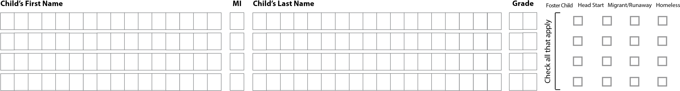
  If you checked any of these boxes, please refer to the Application
  Instruction’s Step 1: Part C & Part D.
STEP 2 | Do any household members (including you) participate in: SNAP, TANF, or FDPIR?
NO Go to STEP 3. YES Write case number here and proceed to STEP 4.
Write only one case number in this space.
STEP 3 | List ALL household members and income for each member (before taxes and deductions)
A. All Adult Household Members (Anyone who is living with you and shares income and expenses, even if not related, including you.)
List all Adult Household Members not listed in STEP 1 (including yourself ) even if they do not receive income. For each Household Member listed, if they receive income, report total gross income (before taxes and deductions) for each source in whole dollars (no cents) only. If they do not receive income from any source, write ‘0’. If you enter ‘0’ or leave any fields blank, you are certifying (promising) that there is no income to report.
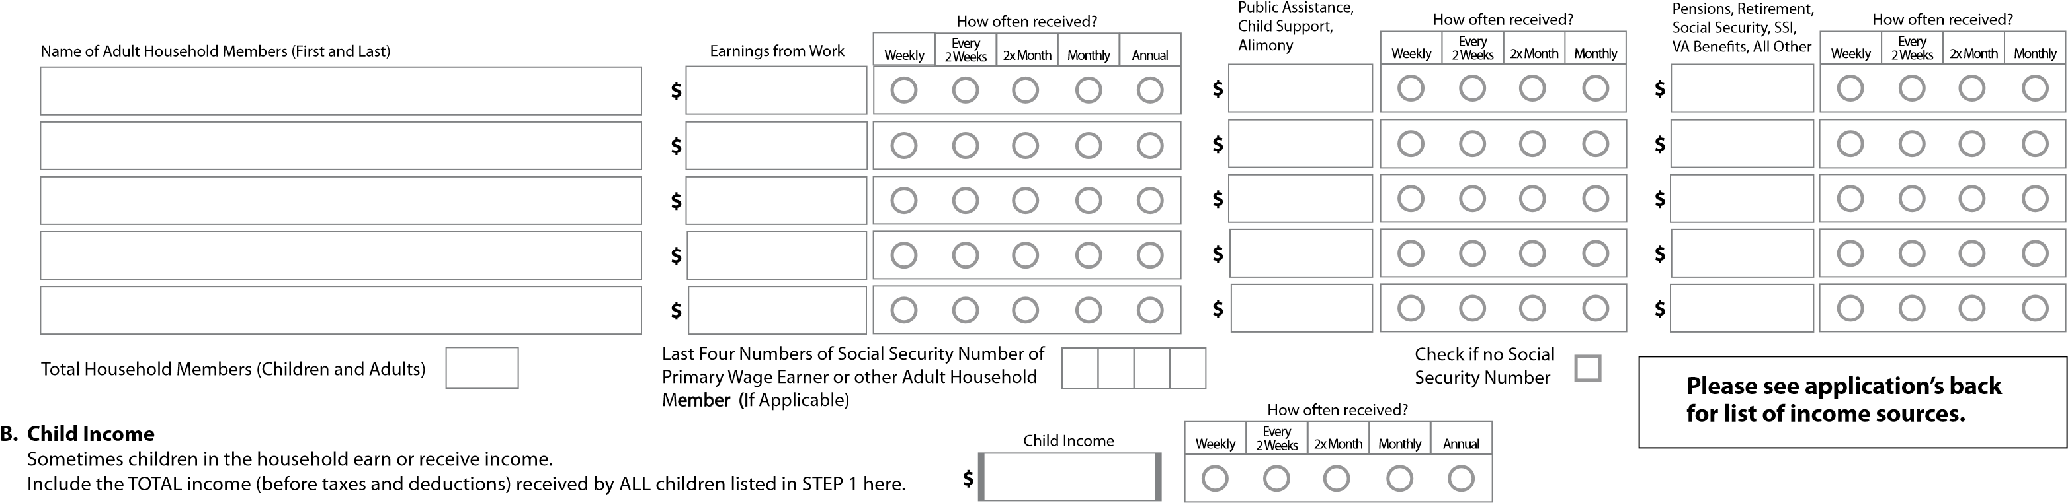
STEP 4 | Contact information and adult signature. | RETURN COMPLETED FORM TO YOUR CHILD’S SCHOOL: | Insert school address here
“I certify (promise) that all information on this application is true and that all income is reported. I understand that this information is given in connection with the receipt of Federal funds, and that school ofcials may verify
(confrm) the information. I am aware that if I purposely give false information, my children may lose meal benefts, and I may be prosecuted under applicable State and Federal laws.”
Print Name of Adult Signing the Form
Signature of Adult
Today’s Date
Mailing Address (if available) City State Zip Phone (optional) Email (optional)
Return completed form to your child’s school.
SOURCES AND EXAMPLES OF INCOME |  |  | For additional information on income, please refer to the instructions that accompany this application.
 | Sources of Income |  |  |  |  | Examples of Income for Children
 | Earnings from Work | Public Assistance/Alimony/ Child Support |  | Pensions/Retirement/  All other sources of income |  | • A child has a regular full or part-time job where they earn a salary or wages
 | - Salary, wages, cash bonuses, tips, commissions  - Net income from self-employment  (farm or business)  If you are in the U.S. Military:  - Basic pay and cash bonuses (do NOT include combat pay, FSSA, or privatized housing  allowances)  - Allowances for of-base housing, food, and clothing | - Unemployment benefts  - Workers' compensation  - Supplemental Security Income (SSI)  - Cash assistance from State or local government  - Alimony payments  - Child support payments  - Veterans benefts  - Strike benefts |  | - Social Security/Disability (including railroad retirement and black lung benefts)  - Private Pensions or disability benefts  - Income from trusts or estates  - Annuities  - Investment income  - Earned interest  - Rental income  - Regular cash payments from outside household |  | - A child is blind or disabled and receives Social Security benefts  - A parent is disabled, retired, or deceased, and their child receives Social Security benefts
 |  |  |  |  |  | • A friend or extended family member regularly gives a child spending money
 |  |  |  |  |  | • A child receives regular income from a private pension fund, annuity, or trust
No! I DO NOT want information from my Free and Reduced-Price School Meals Application shared with the Department of Workforce Services and Utah State Board of Education to issue Summer EBT benefits. I understand if my information is not shared, I will need to apply with the Department of Workforce Services to determine Summer EBT eligibility.
OPTIONAL | Children’s ethnic and racial identities. This information is kept confdential and may be protected by the Privacy Act of 1974.
We are required to ask for information about your children’s race and ethnicity. This information is important and helps to make sure we are fully serving our community. Responding to this section is optional and does not afect your children’s eligibility for free or reduced price meals.
Ethnicity (check one): Hispanic or Latino (A person of Cuban, Mexican, Puerto Rican, South or Central American, or other Spanish Culture or origin, regardless of race) Not Hispanic or Latino
Race (check one or more): American Indian or Alaska Native Asian Black or African American Native Hawaiian or Other Pacifc Islander White
Return this completed form to your child’s school. *Do not mail, fax, or email completed applications to the U.S. Department of Agriculture Ofce of the Assistant Secretary for Civil Rights.
DO NOT FILL OUT | For school use only.
Annual Income Conversion: Weekly × 52, Every 2 Weeks × 26, Twice a Month × 24, Monthly × 12. Do not annualize income to determine eligibility unless more than one income frequency is listed.
^{How often?} Eligibility
Weekly | Every 2 Weeks | 2x Month | Monthly | Annual
Free | Reduced | Denied
Total Income Household size

Categorical Eligibility Error Prone
Determining Ofcial’s Signature

Date Confrming Ofcial’s Signature Date Verifying Ofcial’s Signature Date

Use of Information Statement
The Richard B. Russell National School Lunch Act requires that we use information from this application to see who qualifes for free or reduced price meals. We can only approve complete forms. We may share your eligibility information with education, health, and nutrition programs to help them deliver program benefts to your household. Inspectors and law enforcement may also use your information to make sure that program rules are met.
Please be sure to provide the last four numbers of the Social Security number of the adult household member who signs the application. If the adult does not have one, ‘Check if no Social Security Number.’ Applications for a foster child do not need to list a Social Security number. Applications for children in households receiving Supplemental Nutrition Assistance Program (SNAP) or Temporary Assistance for Needy Families (TANF) or Food Distribution Program on Indian Reservations (FDPIR) do not need to list a Social Security number. Some children qualify for free meals without an application. Please contact your school to get free meals for a foster child, and children who are homeless, migrant, or runaway.
Return completed form to your child’s school.
The contact information below is solely to fle a complaint of discrimination
In accordance with federal civil rights law and U.S. Department of Agriculture (USDA) civil rights regulations and policies, this institution is prohibited from discriminating on the basis of race, color, national origin, sex (including gender identity and sexual orientation), disability, age, or reprisal or retaliation for prior civil rights activity. Program information may be made available in languages other than English. Persons with disabilities who require alternative means of communication to obtain program information (e.g., Braille, large print, audiotape, American Sign Language), should contact the responsible state or local agency that administers the program or USDA’s TARGET Center at (202) 720-2600 (voice and TTY) or contact USDA through the Federal Relay Service at (800) 877-8339.
To file a program discrimination complaint, a Complainant should complete a Form AD-3027, USDA Program Discrimination Complaint Form which can be obtained online at: https://www.usda.gov/sites/default/files/documents/ad-3027.pdf, from any USDA office, by calling (866) 632-9992, or by writing a letter addressed to USDA. The letter must contain the complainant’s name, address, telephone number, and a written description of the alleged discriminatory action in sufficient detail to inform the Assistant Secretary for Civil Rights (ASCR) about the nature and date of an alleged civil rights violation. The completed AD-3027 form or letter must be submitted to USDA by:

*MAIL: U.S. Department of Agriculture FAX: (833) 256-1665 or (202) 690-7442; or *Do not mail applications
Ofce of the Assistant Secretary for Civil Rights EMAIL: program.intake@usda.gov to this address,
1400 Independence Avenue, SW only complaints of Washington, D.C. 20250-9410 ^{discrimination.}
This institution is an equal opportunity provider.

